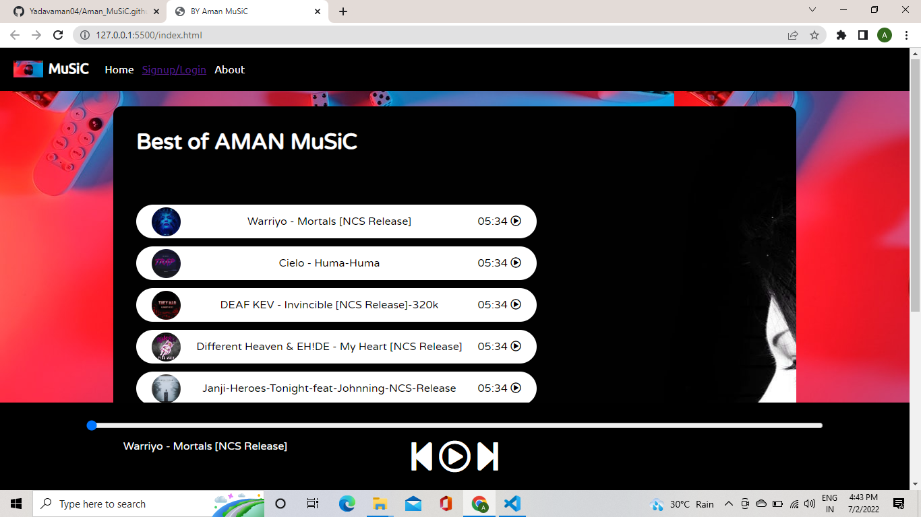

**1.Home page with NCS having 3 songs.**

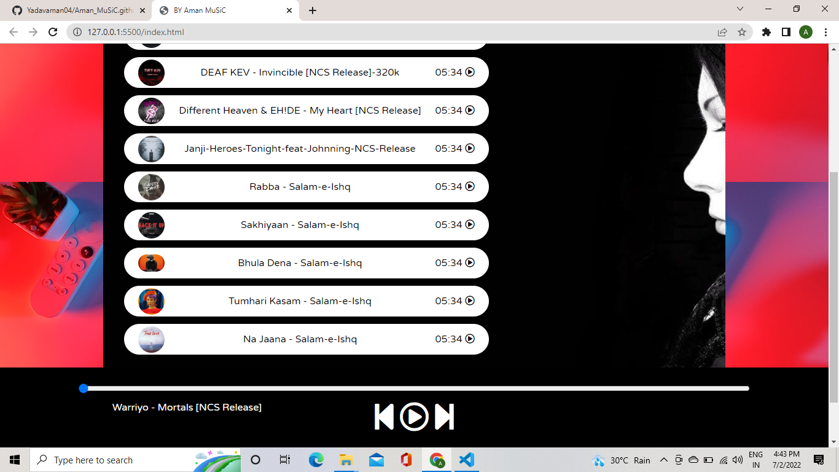

2.HOME PAGE with Salam-e-Ishq having 5 songs (considering having salam-e-as a author)

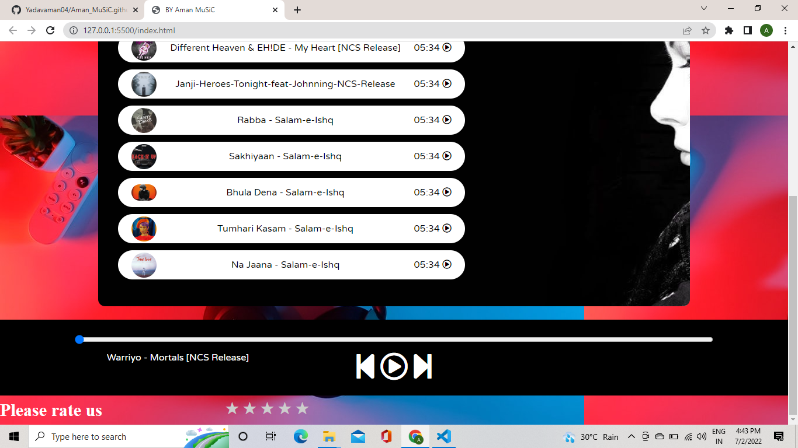

3. Here song is paused and also rating is given to rate the website.

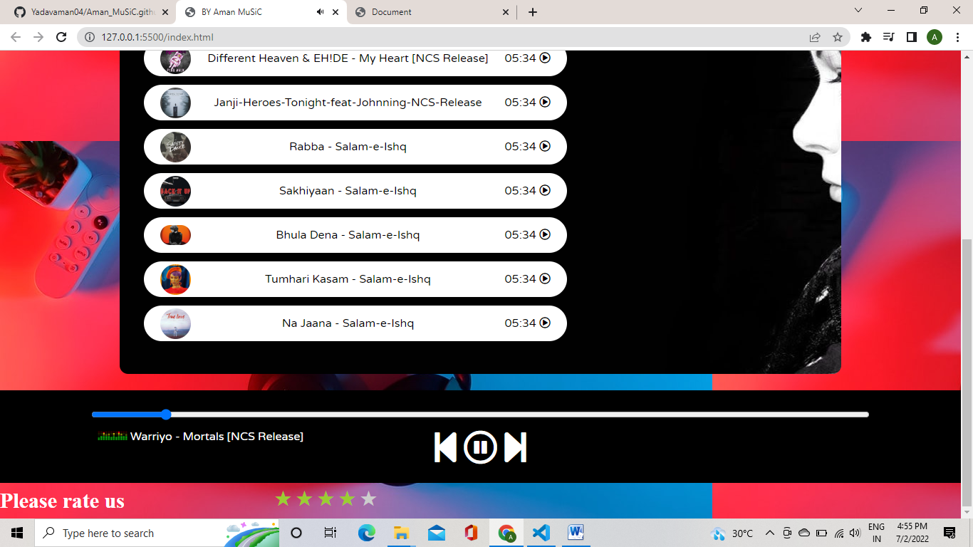

4. Here the song is playing and also the website is rated by the user.

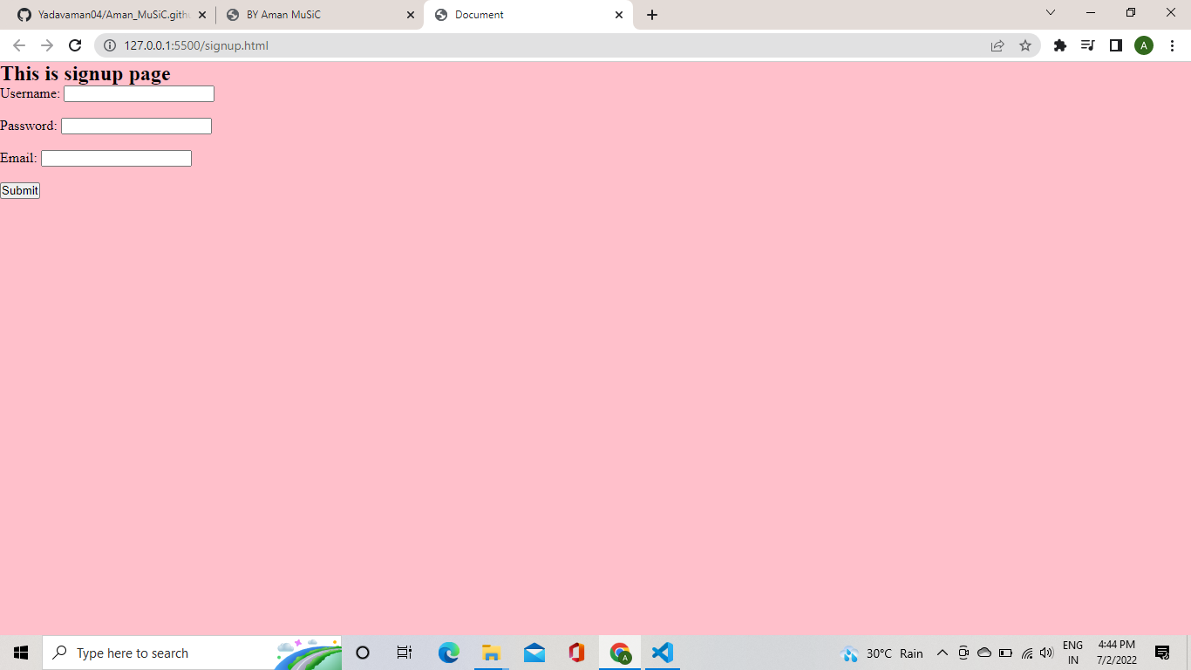

5. The login page. The signup option available next to home tab.